Screenshots:

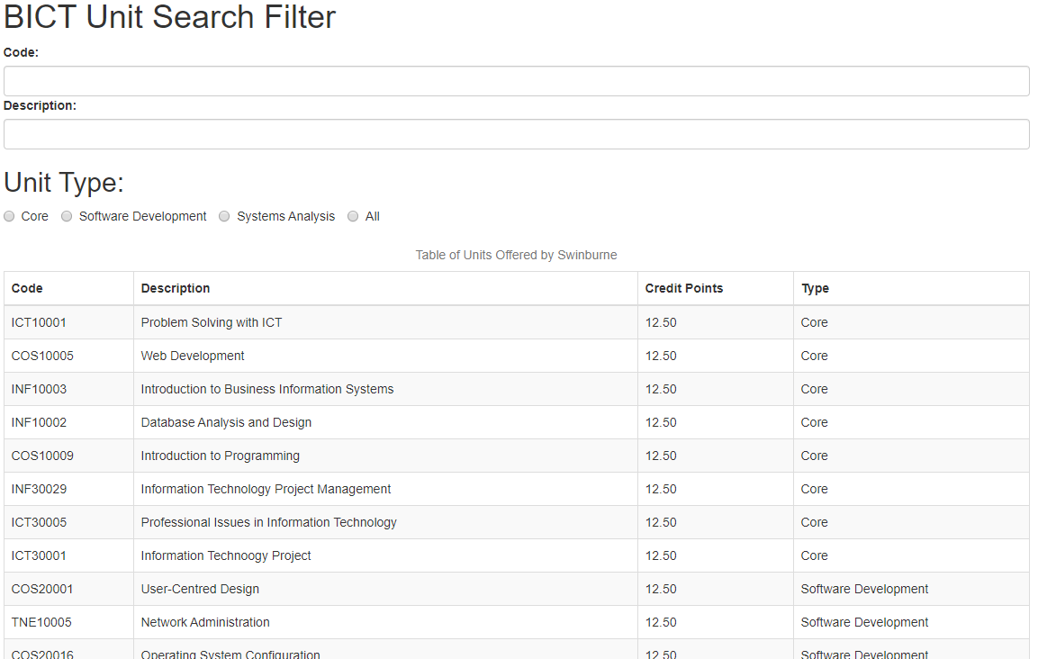
Figure 1: Webpage on Initial Load

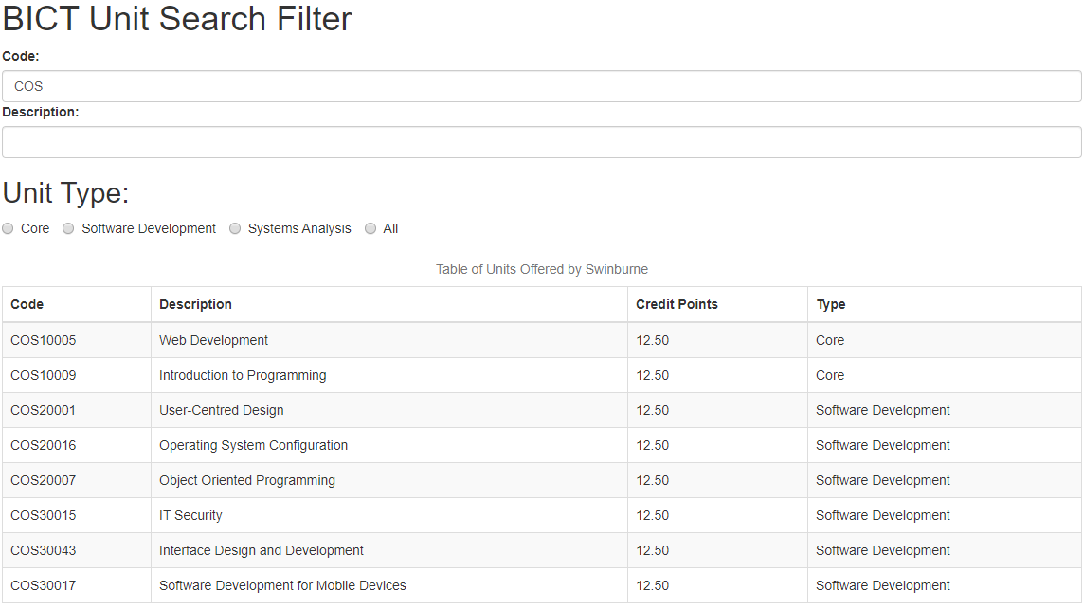
Figure 2: Unit Code Filter

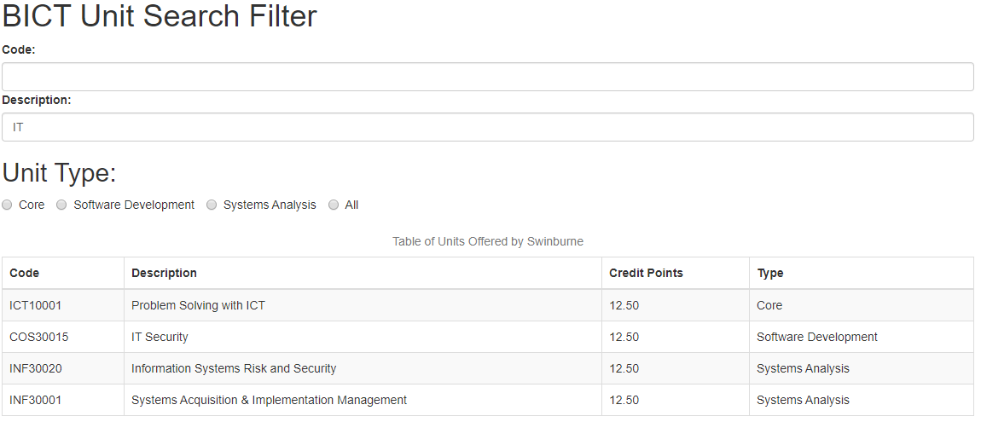
Figure 3: Unit Description Filter

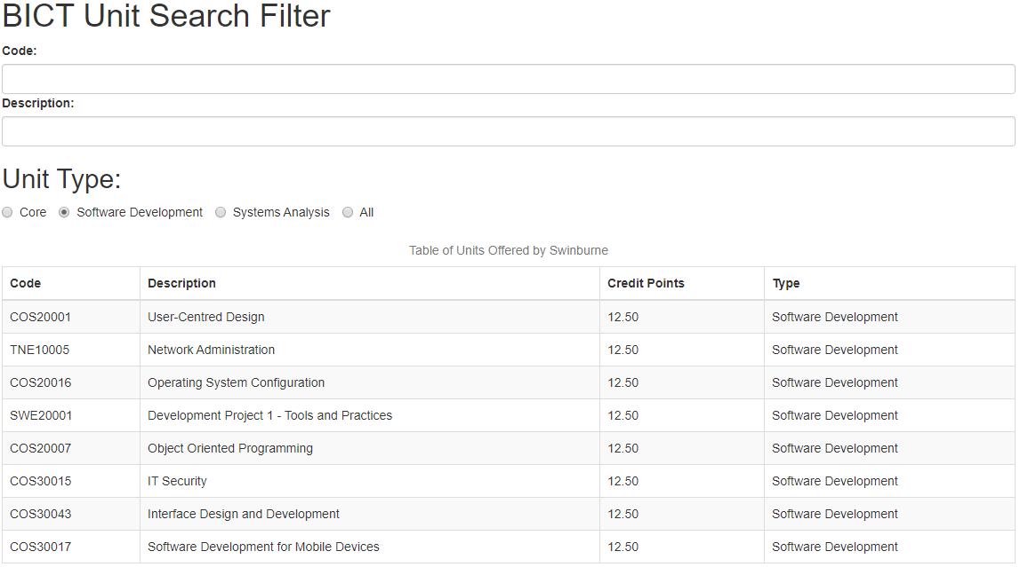
Figure 4: Unit Type Filter

